Japan's Earthquake Ranks as the Fifth Strongest in the World Since 1900

By: Megan Gibson
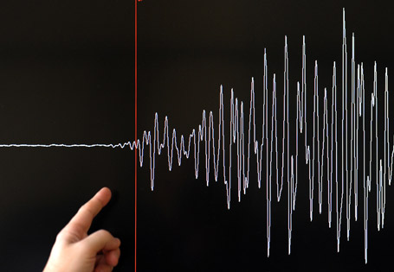
Getty Images.
The massive 8.9-magnitude earthquake that hit off the coast of Japan is not only the biggest quake for the country on record, but scientists are now saying it's the fifth biggest quake in the world in more than a century.
According to the U.S. Geological Survey, the previous quake in the fifth spot was last year's quake just off-shore of Chile. That quake came in at 8.8 on the Richter scale, which means that Japan's 8.9 quake is the new number five, right behind 1952's earthquake in Kamchatka, Russia. (That one came in at 9.0)
(More on TIME.com: See photos of Japan's Earthquake)
So far in Japan, more than 80 aftershocks with a 5.0-magnitude or greater have been felt since the initial quake.
For more on the earthquake and Japan's rescue efforts see Lucy Birmingham's coverage from Tokyo.
http://newsfeed.time.com/2011/03/11/japans-earthquake-ranks-as-the-fifth-strongest-in-the-world-since-1900/

